Southern Illinois University and

Universities Council on Water Resources present
Scaling solutions: Beneficially utilizing treated
produced water for agriculture
with Dr. Joseph Burke and Dr. Katie Lewis

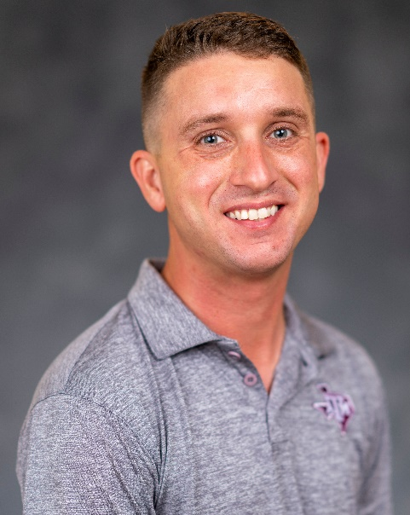
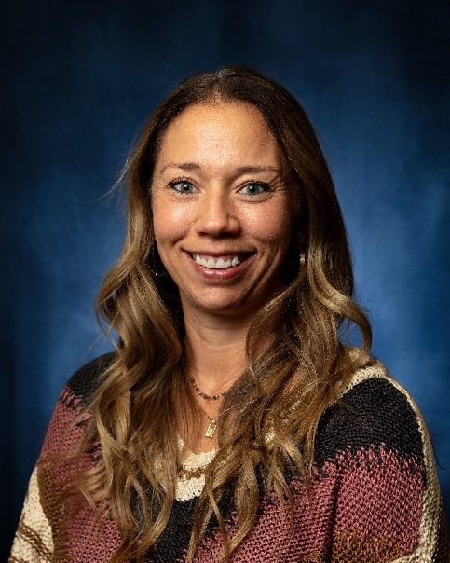

Dr. Joseph Burke
Assistant Professor of Cropping Systems Agronomy and Extension Soil and Water Specialist, Texas A&M AgriLife Research and Extension Service, Lubbock, TX
Dr. Katie Lewis
Professor of Soil Chemistry and Fertility, Texas A&M AgriLife Research,
Lubbock, TX

Texas A&M AgriLife leads two projects to better understand how treated

produced water can be used beneficially for agriculture. These projects integrate

research and extension to characterize the treated produced water, examine its

impact on forage, bioenergy, and row crop production, evaluate changes in soil chemical, physical, and biological properties, quantify economic impacts, and model changes in regional hydrology due to produced water applications.

This virtual seminar series is free and open to the public.
Tuesday, October 28th, 2025, 12PM CT on Microsoft Teams
Click here to register and join the conversation.


