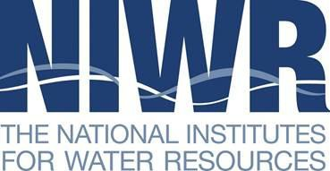

Region Breakout Session Notes

**NIWR 2024 Fall Virtual Meeting October 29, 2024, 3:20–4:00 pm ET**

**NIWR Board Representative:**

**Attendance:**

**Suggested Discussion:**

* Introductions (5 minutes)
* Success Stories (10 minutes), Questions from New Directors
* Regional Activities (10 minutes)

1. Opportunities to advance collaboration between NIWR institutes and USGS Water Science Centers in your region
2. Plans for use of increased 104b funds, possibility of joint RFPs

* NIWR-wide Issues. Respond to the following discussion prompts (10 minutes):

1. What can NIWR do to help communicate the impacts of increased WRRA appropriations over the past several years?
2. What topics do you recommend for the agenda when we gather for the annual NIWR meetings in DC in February 2025?

* Other Topics (5 minutes)

**Note about reporting to the main session (4:00–4:30 pm):** We will have a short period following the breakouts for regions to share key points from your discussions, including how best to use time at the annual meeting in DC. Regional board representatives (or their designees) will be asked to share one top suggestion for an annual meeting topic (3 minutes per region).